Involve Selection Ltd / Vocate Training
SAFEGUARDING POLICY
Introduction
1. Involve Selection Ltd is committed to the safeguarding and well-being of all of our learners and fully recognises its responsibilities for protecting vulnerable groups. Our policy applies to all staff, learners, contractors, visitors and working on behalf of or in conjunction with Involve Selection Ltd
2. It is the policy of Involve Selection Ltd to promote the safety, health and well-being of all children, young people and vulnerable adults that the organisation works with – both directly and indirectly. We respect, value and listen to everyone as an individual.
3. Involve Selection Ltd will do this through:
● Training
● Staff meetings and peer coaching
● Recruitment
● Reporting
● Reviewing
● Engaging
● Investigation
Support
4.At Involve Selection Ltd we are committed to:
● Raising awareness of safeguarding throughout the organisation and ensuring that staff are equipped with the appropriate skills, training and knowledge to support learners effectively and help to keep them safe
● Raising awareness of safeguarding to all of our learners and ensuring that the learners who are most vulnerable are equipped with the skills and knowledge needed to keep them safe
● Implementing procedures for identifying and reporting cases or suspected cases of e issues
● Establishing safe environments in which vulnerable groups can learn and develop
5. We recognise that because of the day to day contact with learners, our staff are well placed to observe the outward signs of abuse. Involve Selection Ltd will therefore:
● Establish and maintain an environment where learners feel secure, are encouraged to talk and are listened to Safeguarding Policy
● Include opportunities within our ongoing assessment and review process including classroom delivery, for learners to develop the skills they need to recognise and stay safe from any safeguarding issues
6. Involve Selection Ltd recognises and adheres to the statutory requirements within the following important and relevant pieces of safeguarding legislation:
- Keeping children safe in education (2022)
- “Duty of Care” as defined in the Children Act (1989)
- Health & Safety at Work Act (1974)
- Health & Safety First Aid Act (1981)
- Education Act (2002, 2011)
- Counter-Terrorism and Security Act 2015)
- Working Together to Safeguard Children (2018)
- Children’s Act (1989, 2004)
- Safeguarding Children and Safer Recruitment in Education (2007)
- Safeguarding Vulnerable Groups Act SVGA (2006 amended 2012)
- Protection of Freedoms Act (2012)
- Disclosure and Barring Service Code of Practice (2012)
- Sexual Offences Act (2003)
- Every Child Matters (2003)
- Equality Act (2010)
- Female Genital Mutilation Act (2003)
- Apprenticeships, Skills, Children and Learning Act (2009)
- Children and Families Act (2014)

We adhere to good practice with guidance outlined by the NSPCC and the UK Government.
7. To support our commitment to the safeguarding and well-being of all of our learners and with regard to the above legislation we will:
● Ensure that we have a Designated Person for Safeguarding (James Brooklyn) who has received appropriate training and support for this role.
Ensure that all staff through induction and training are aware and understand their responsibilities in relation to Safeguarding and in being alert to the signs and indicators of any form of abuse and for referring any concerns directly to the Designated Person for safeguarding.
All staff are to be inducted and trained on Involve Selection Ltd Safeguarding policy and procedures. This induction training will be revisited and reviewed every year.
8. All learners will be briefed on these procedures.
9.Involve Selection Ltd will:
● Ensure that effective Safeguarding procedures are developed, implemented and monitored to ensure their effectiveness. These procedures are based on the 5R’s approach of Recognition, Response, Record, Report, Refer
● Ensure the Safeguarding Policy and Procedures are in place and kept
● Ensure Safeguarding details are displayed in the office.
● Ensure that we develop effective links with relevant external agencies, local safeguarding boards and co-operate with any requirements with any safeguarding referral matters
● Ensure that we keep written records of safeguarding concerns, even when there is no need to refer the matter to the relevant agencies
● Ensure all records are stored securely and in accordance with GDPR
10. Involve Selection Ltd recognises its responsibility with regard to the safeguarding of young and vulnerable learners from any form of abuse and from inappropriate and inadequate care and is committed to responding in all cases where there is concern.
11. Due to the nature of our work Involve Selection Ltd may be in the frontline of work with some children, young learners, vulnerable learners and vulnerable adults. This may mean that we are the first to know that a child, young or vulnerable learner or adult is at risk of or being abused or that we are concerned about a person’s well-being.
Everyone has an equal responsibility to ensure that the individual needs and welfare of the person are put first and to safeguard any person with whom we may come into contact.
12. We will ensure that our Safeguarding Policy and Procedures are reviewed at least annually to ensure that they are still relevant and effective.
What is Safeguarding?
13. Safeguarding is a proactive process of protecting and ensuring the safety and well-being of young and vulnerable learners. Safeguarding may involve instances in which a young or vulnerable learner is suffering or likely to suffer from harm. Safeguarding involves adopting safer recruitment practices to assist in identifying persons who are unsuitable to work with young or vulnerable learners.
What are the benefits of effective Safeguarding?
14. Benefits of safeguarding:
● When learners feel safe and secure they can concentrate on learning.
● Learners can rely on those people in positions of trust.
● Staff are protected from malicious and misplaced allegations.
● Staff are clear about individual responsibilities, roles and boundaries.
● Learners are appropriately protected and all issues are dealt with effectively.
● Clear ‘whistleblowing’ procedure to raise concerns and report on any wrongdoing perpetrated by another employee
Definition and types of Safeguarding Concerns
15. This section closely reflects the procedures and guidance in NSPCC Safeguarding definitions Board and the Home Office document “Working Together to Safeguard Children” 2018. ‘Child abuse and neglect’ is a generic term encompassing all ill treatment of young and vulnerable learners, including serious physical and sexual assaults as well as cases where the standard of care does not adequately support the person's health or development. Abuse and neglect are forms of maltreatment of a young or vulnerable learner. Somebody may abuse a young or vulnerable learner by inflicting harm, or by failing to prevent harm. Young or vulnerable learners may be abused in the family or an institutional or community setting by those known to them or, more rarely, by a stranger. An adult or adults or another child or children may abuse them.
16. The NSPCC Guidelines Working Together to Safeguard Children (2010) sets out definitions and examples of the four broad categories of abuse:
● Physical Abuse
● Emotional Abuse
● Sexual Abuse
● Neglect
Physical Abuse
17. Physical abuse may involve hitting, shaking, throwing, poisoning, burning or scalding, drowning, suffocating or otherwise causing physical harm. Physical harm may also be caused when a parent or carer fabricates the symptoms of, or deliberately induces illness.
Emotional Abuse Safeguarding Policy
18. Emotional abuse is the persistent emotional maltreatment of a person such as to cause severe and persistent adverse effects on their development. It may involve conveying to the person that they are worthless or unloved, inadequate or valued only in so far as they meet the needs of another person. It may feature age or developmentally inappropriate expectations being imposed in them.
19. These may include interactions that are beyond the person’s developmental capacity, as well as overprotection and limitation of exploration and learning, or preventing them participating in normal social interactions. It may involve serious bullying causing the person frequently to feel frightened or in danger, or the exploitation or corruption of persons. Some level of emotional abuse is involved in all types of maltreatment of a person, though it may occur alone. This also includes include E-safety.
Sexual Abuse
20. Sexual abuse involves forcing or enticing a person to take part in sexual activities, including prostitution, whether or not the person is aware of what is happening. The activities may involve physical contact, including penetrative or non-penetrative acts. They may include non-contact activities, such as involving them in looking at, or in the production of, pornographic material or watching sexual activities, or encouraging sexually inappropriate behaviour.
Neglect
21. Neglect involves the persistent failure to meet a person’s basic or physical and/or psychological needs, likely to result in the serious impairment of the person’s health and development. Neglect may occur during pregnancy as a result of maternal substance abuse. Once a child is born, neglect may involve a parent or carer failing to provide adequate food and clothing, shelter including exclusion from home or abandonment, failing to protect a person from physical harm or danger, failure to ensure adequate supervision including the use of inadequate care-takers, or the failure to ensure access to appropriate medical care or treatment. It may also include neglect of, or unresponsive to, a person’s basic emotional needs.
22. Additional safeguarding concerns and unsafe activities which we recognise, and which have become more prevalent in recent times are:
● Bullying and Harassment
● Sexting
● Discriminatory Abuse
● Financial Abuse
● Grooming
● Domestic Violence Alcohol and Drugs
● Online abuse
● Crime
● Cyber-bullying Safeguarding Policy
● Radicalisation and Extremism – more about this can be found in our PREVENT policy
Signs and Indicators of Possible Abuse
23. When considering whether there is enough information and evidence to suggest a young or vulnerable learner has been abused, there are a number of possible indicators. However there may also be a perfectly reasonable explanation so it is important to remain vigilant but not be overzealous nor jump to conclusions. There may also be no signs or indicators or abuse, however this does not necessarily mean that a report of abuse is false.
Signs Suggesting Physical Abuse
24. Signs suggesting Physical Abuse may include but are not limited to:
● Any injuries not consistent with the explanation given for them
● Injuries that have occurred on parts of the body which are unusual and not indicative of a fall or because of playing a contact / rough sport etc.
● Injuries that have not received medical attention
● Neglect – under nourishment, failure to grow, constant hunger, stealing or gorging food, untreated illnesses, unkempt appearance, dirty clothes etc.
● Changes in routine
Signs Suggesting Sexual Abuse
25. Signs suggesting Sexual Abuse may include but are not limited to:
● Any sexual allegation made by an individual
● Individuals with an excessive preoccupation with sexual matters and detailed knowledge of adult sexual behaviour
● Sexual activity through words, play or drawing
● Individuals who are sexually provocative or seductive
● Severe sleeping disorders
● Eating disorders
Signs Suggesting Emotional Abuse
26. Signs suggesting Emotional Abuse may include but are not limited to:
● Changes or regressions in mood or behaviour
● Nervousness
● Obsessions or phobias
● Sudden under-achievement or lack of concentration
● Attention seeking behaviour
● Persistent tiredness

Safeguarding Procedure Flowchart
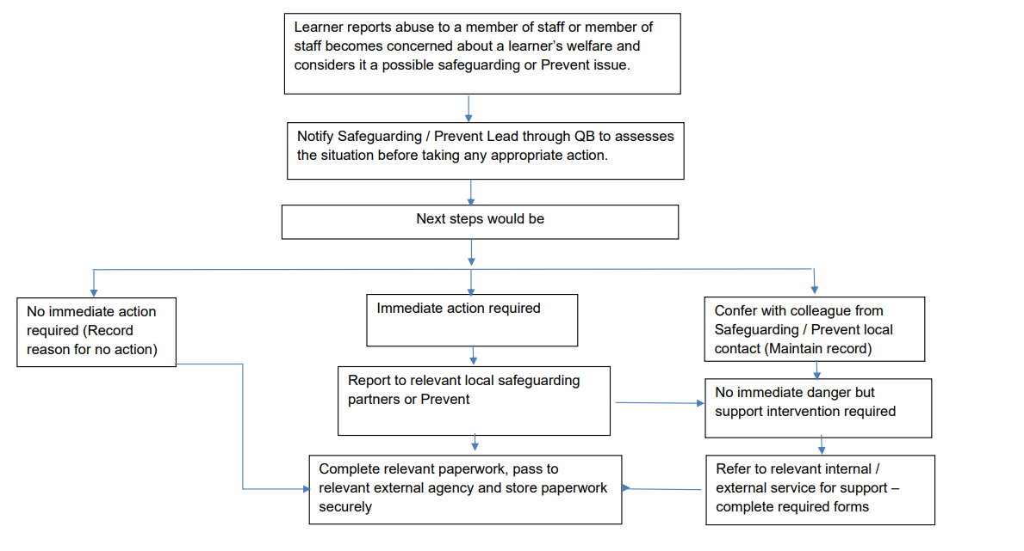
This policy will be kept up to date, will be reviewed at least annually and is signed by Involve Selection Ltd.’s Designated Safeguarding Lead James Brooklyn:

James Brooklyn
Designated Safeguarding Lead
October 2022

